

**武汉一沃生物科技有限公司**

eGFP-mRNA（N1-Me-Pseudo UTP）

Cat.No.:ER1001 Size: 50μg/200μg/500μg/1mg

Con.:1mg/mL Store at -20℃（not frost-free）

Product Overview

eGFP protein (enhanced green fluorescent protein) is a commonly used reporter molecule that emits strong and bright green fluorescence upon excitation by light, with maximum excitation/emission wavelengths of 488 nm/509 nm, respectively. When transfected into cells, the eGFP mRNA product enables the expression of eGFP protein in the cells, facilitating the study of transfection and expression within cells.

Product Composition

|  |  |  |
| --- | --- | --- |
| Cat.No | Product Name | Formulation |
| ER1001 | eGFP mRNA（N1-Me-Pseudo UTP） | Enzyme-free aqueous solvent, 1mg/mL mRNA |

Usage Instructions

Cell Experiment Reference Steps:

1. Digest cells and seed them into a 12-well plate at a density of 5x10^5 cells per well with 1mL of culture medium. Transfection can be performed when the cell growth density exceeds 80%.

2. Prepare mRNA-transfection reagent and add it to the cells at a dosage of 0.5-2μg per well. Incubate at 37°C in a 5% CO2 cell culture incubator for 6-8 hours. After incubation, replace the medium with complete culture medium and continue incubating.

3. After transfection for 12 hours, use a fluorescence microscope to image eGFP expression, which can serve as an indicator for mRNA transfection efficiency validation. Alternatively, after transfection, cells can be harvested, centrifuged, and resuspended for flow cytometry analysis of eGFP fluorescence expression.

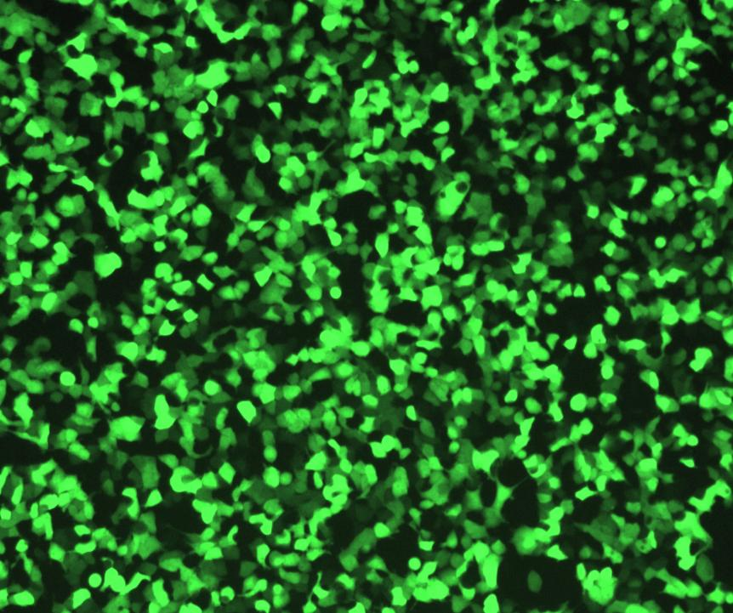

Figure 1: Fluorescence Expression of eGFP mRNA Transfected into 293T/17 Cells After 12 Hours

Notes

1. Storage Conditions: mRNA can be stored for 6 months at -20°C and for 12 months at -80°C.

2. Avoid repeated freeze-thaw cycles of mRNA. If repeated freeze-thawing and repeated use are necessary, aliquot the mRNA upon first use.

3. During the experiment, use RNase-free reagents and consumables throughout the entire process, and adhere to standardized operations in an RNase-free environment.

References

**此处插入公司slogan**

**此处插入公司联系方式**